Tenant Move-In Process for November 15th

1. Identify Tenant Move-In Date 0:00
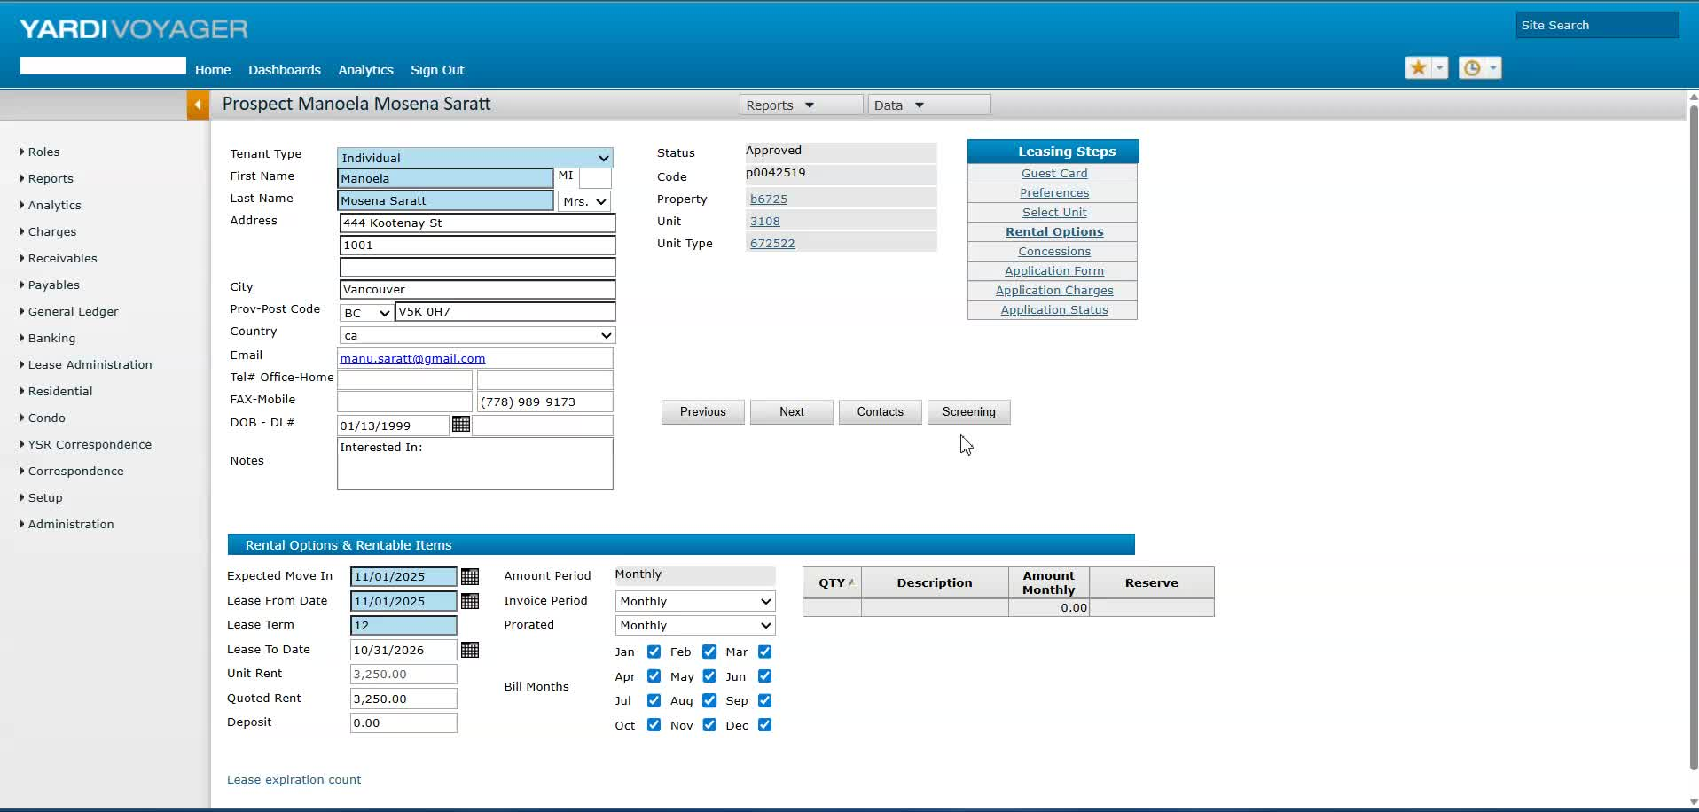
- Confirm the tenant's approved move-in date (e.g., November 15th for Manola and Matthew).
- Note that no need to contact Brenda for changes.

2. Access the Prospect Page 0:13
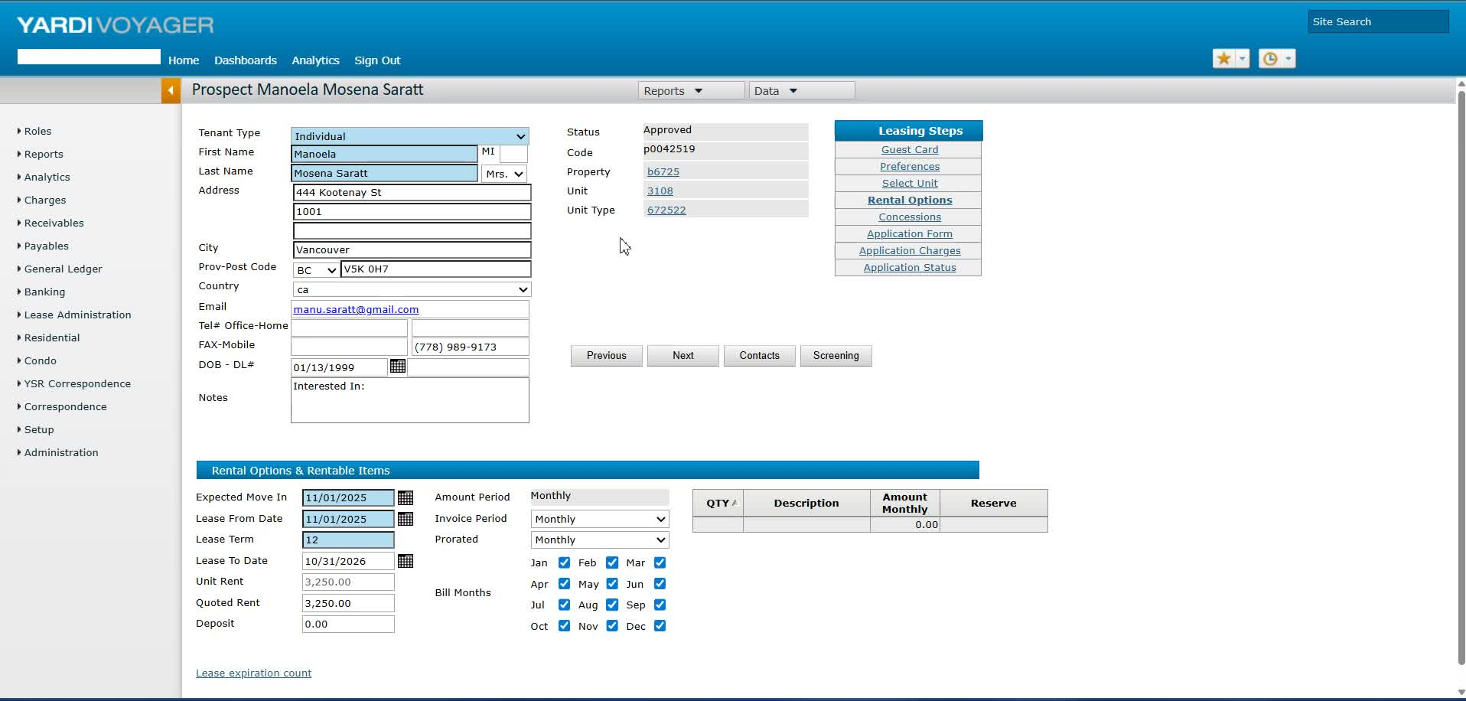
- Navigate to the home page and access the prospect page.

3. Check for Changes in Yardy 0:28
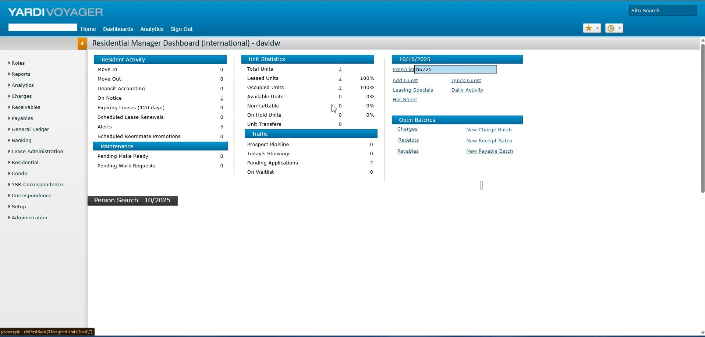
- Understand that changes cannot be made directly if the back office is locked.
- Only light changes can be made.

4. Go to Pending Applications 0:42
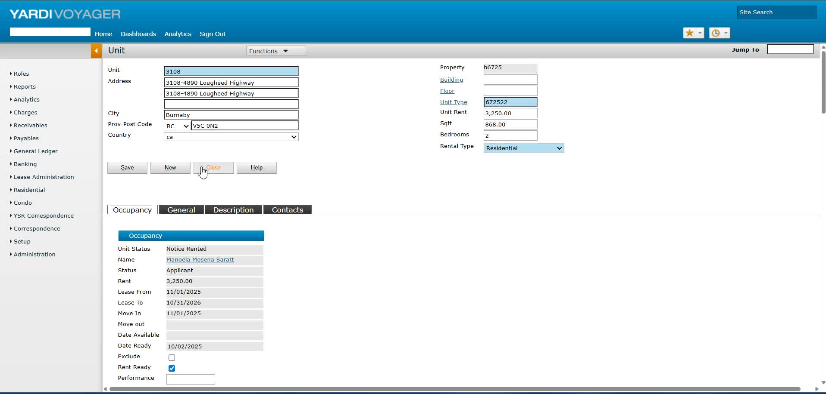
- Access the pending applications section since the tenancy agreement has not been generated yet.

5. Update Rental Options 0:54
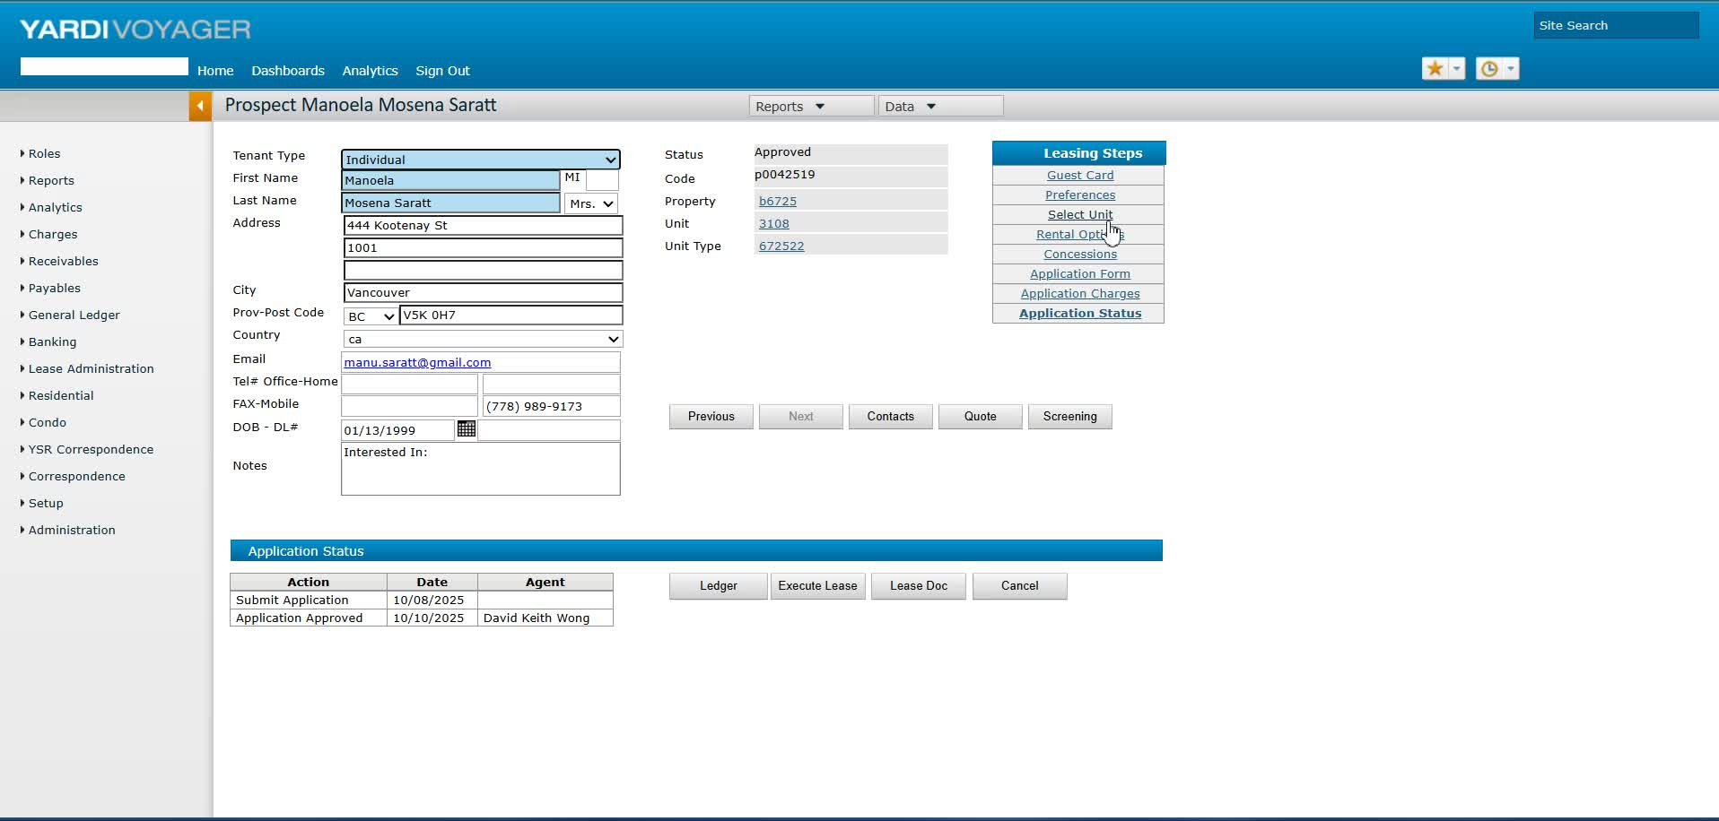
- Select the unit and update the expected move-in date to November 15th.
- Set the lease date to November 30th, as tenants pay for the full month regardless of move-in date.

6. Review Deposit and Charges 1:30
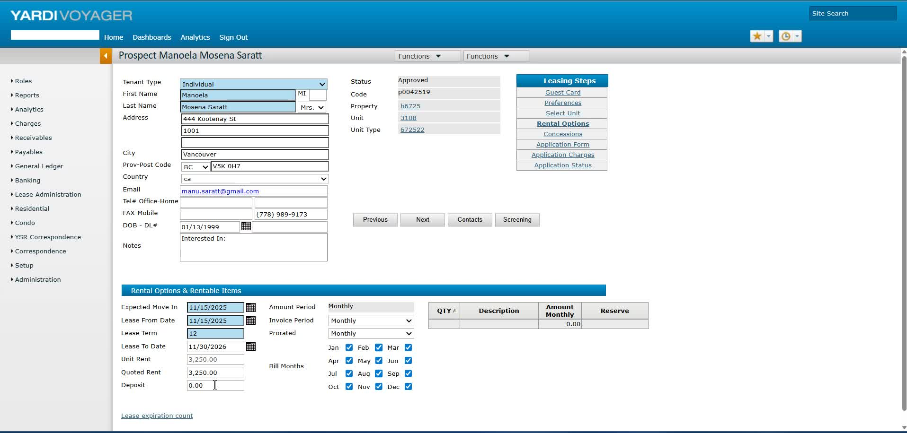
- Note that the deposit information may not be significant at this stage.

7. Confirm Application Details 1:59
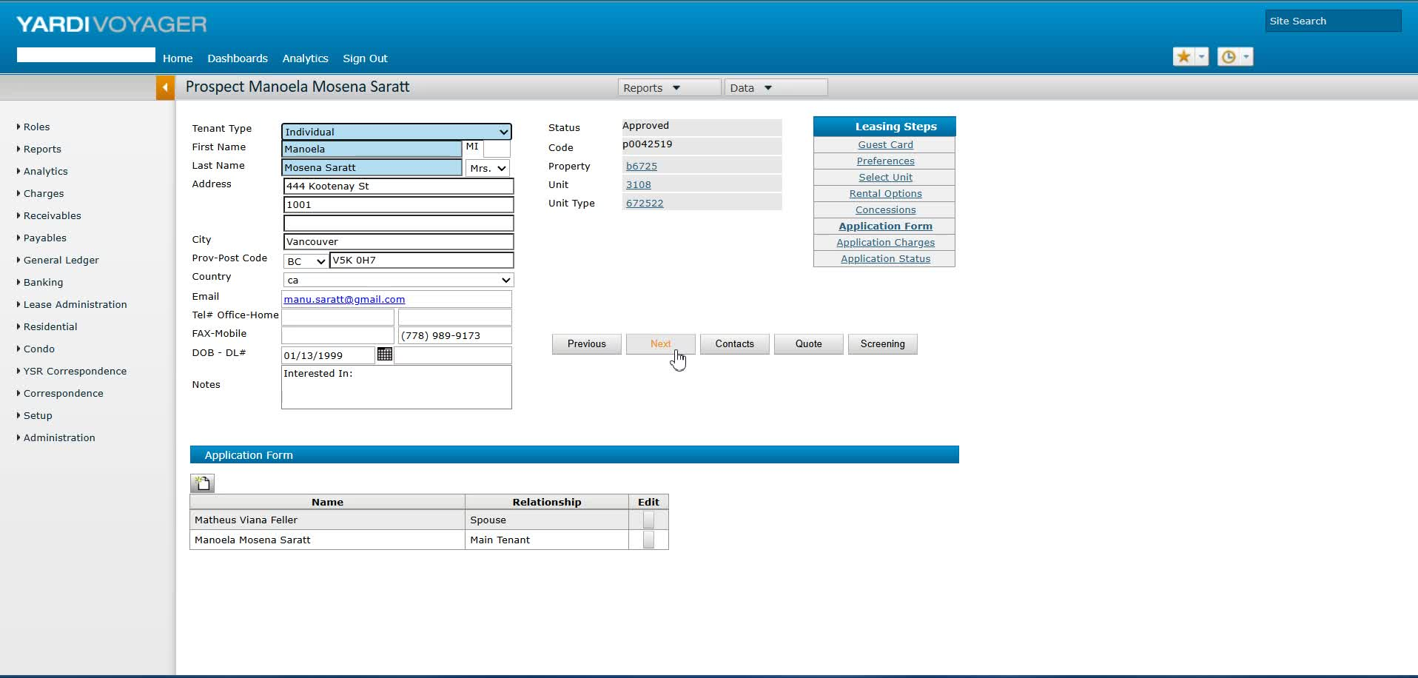
- Check the application charge and ensure all details are correct before generating the tenancy agreement.

8. Verify Contact Information 2:16
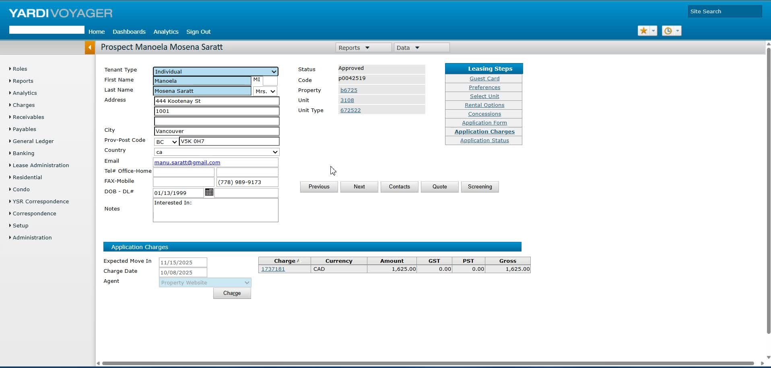
- Ensure phone numbers are correctly displayed, as there may be issues with mobile numbers.

9. Save Tenant Information 3:04
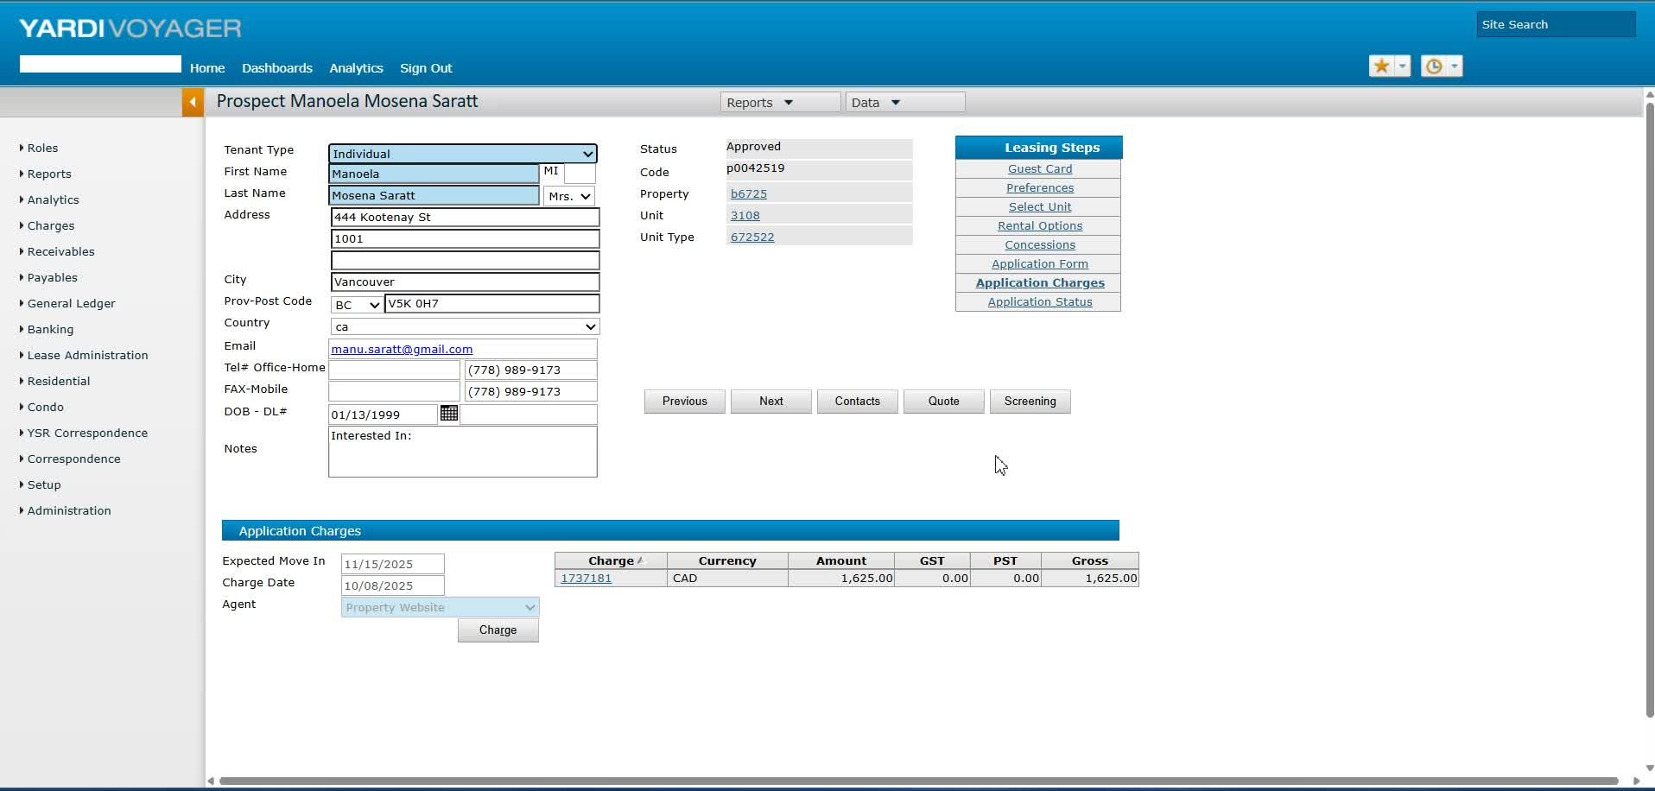
- Save the tenant's information to ensure it is locked in.

10. Access RENCAFE for Updates 3:18
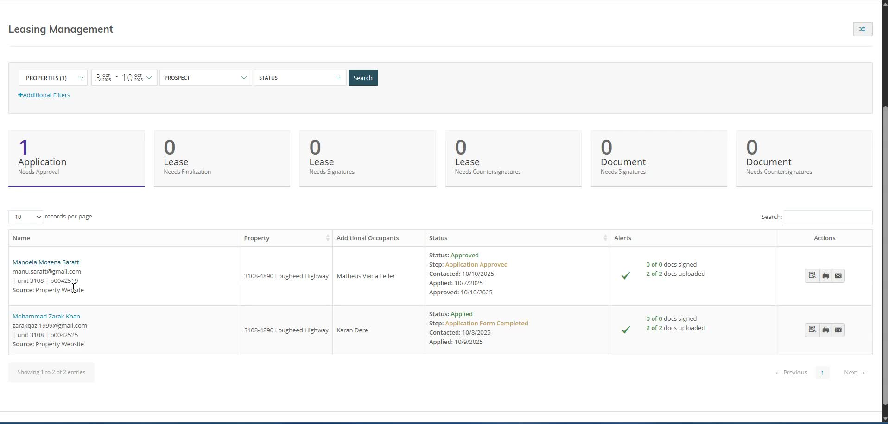
- Launch RENCAFE and check that the move-in date has updated to the 15th.

11. Generate Tenancy Agreement 3:36
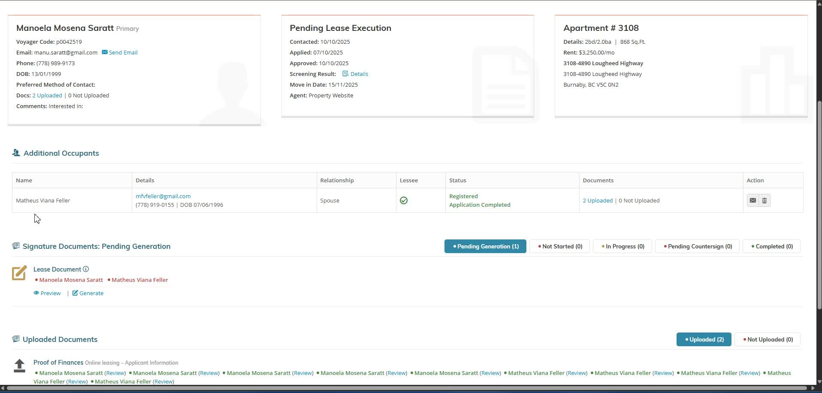
- Confirm that all necessary information is present before generating the tenancy agreement.

12. Review Prorated Rent and Payments 4:01
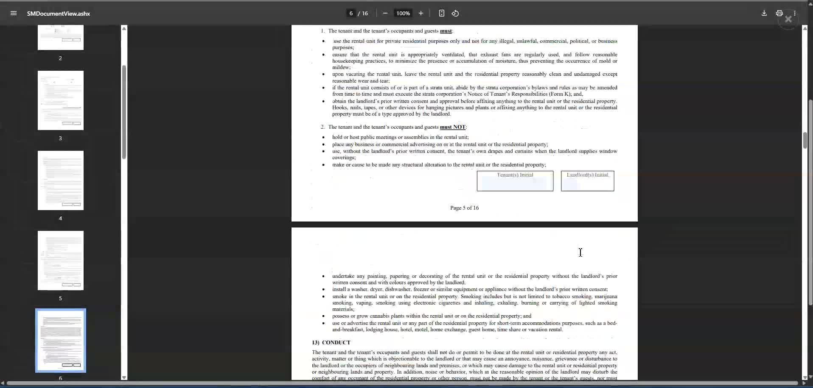
- Check for any prorated rent and ensure payment details are accurate.

13. Verify Additional Agreements 4:12
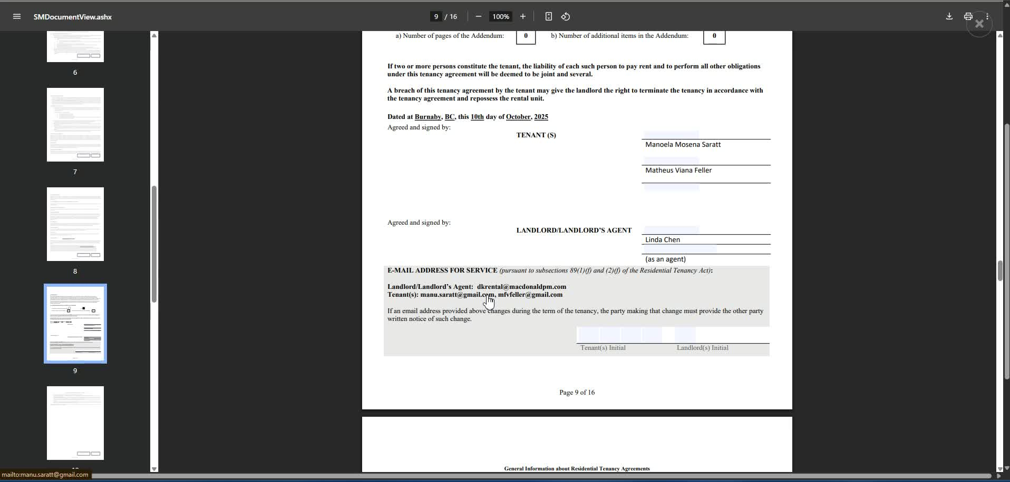
- Double-check emails and contact information.
- Review parking and storage locker agreements.

14. Finalize and Save Documents 4:50
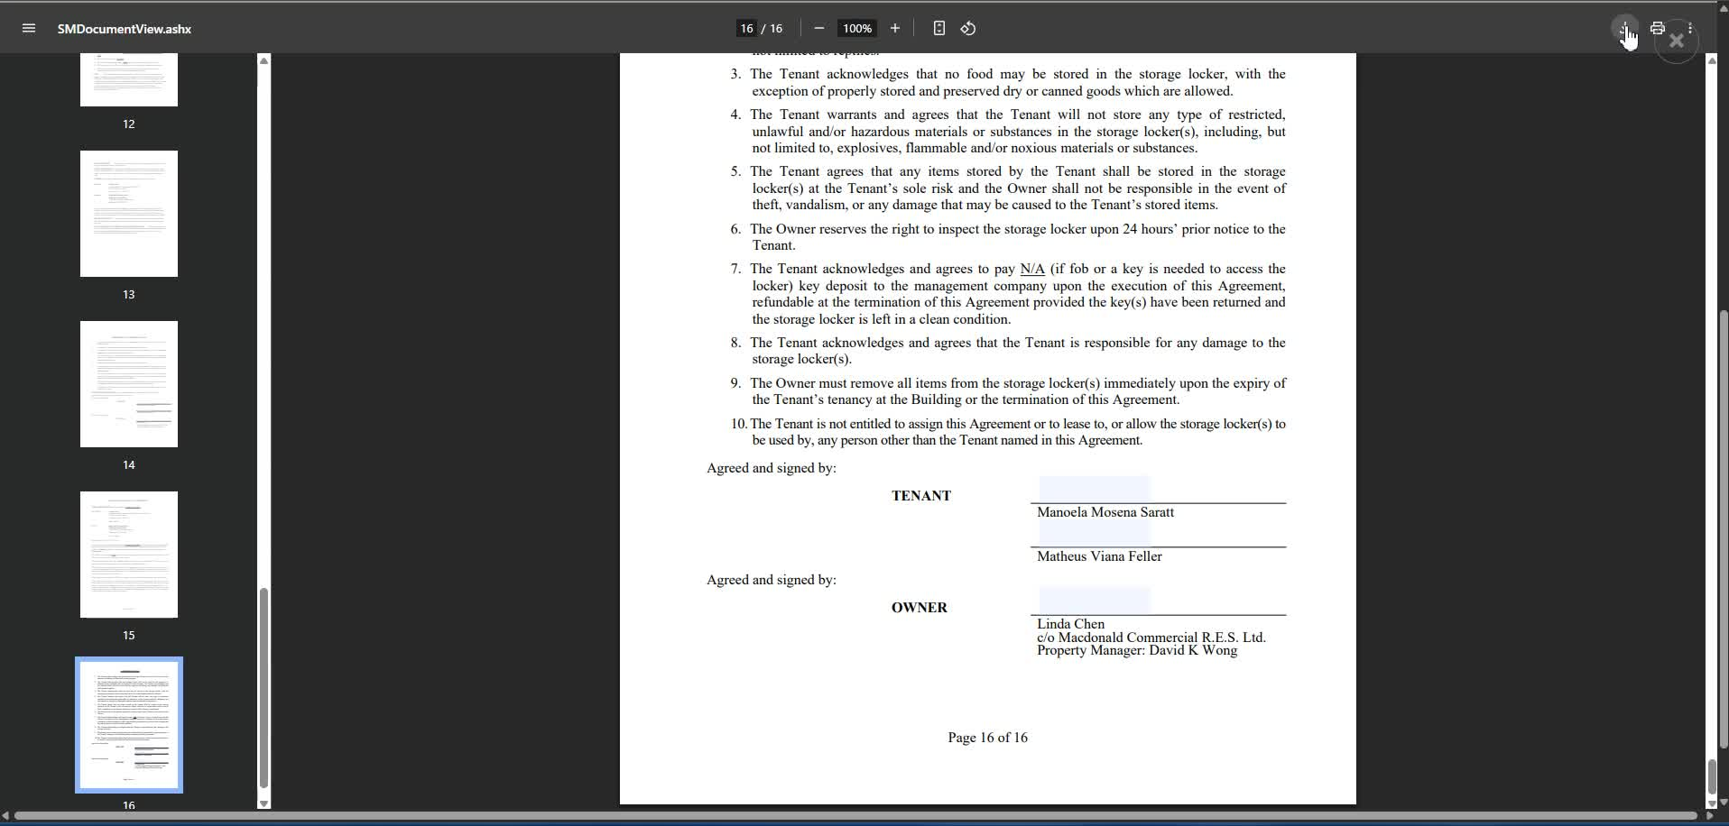
- Save all documents in the appropriate subfolder.
- Clean up documents before sending them off for signature.
Link to Loom
https://loom.com/share/d0b7b718db7b45a1a4c7c500ff9cdaff

